Design review 2 PDU Akshdeep

Canduino

+5V is not listed on any other sheet, where is this power from?

PCB

What is the plan for the regulators? Standing or lying down?

Why is 5V2 fuse not aligned up?

RBRB is not connected by the fuses

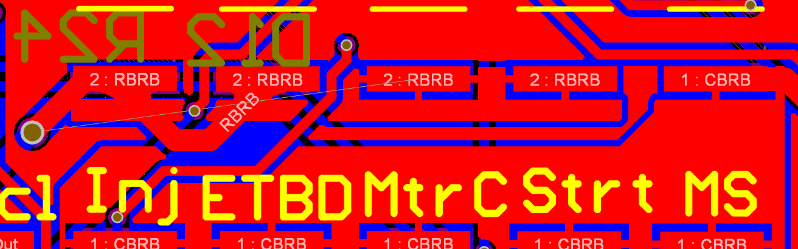 3

Lots of unrouted pins on the PCB

The routing is in strange places near pins and components

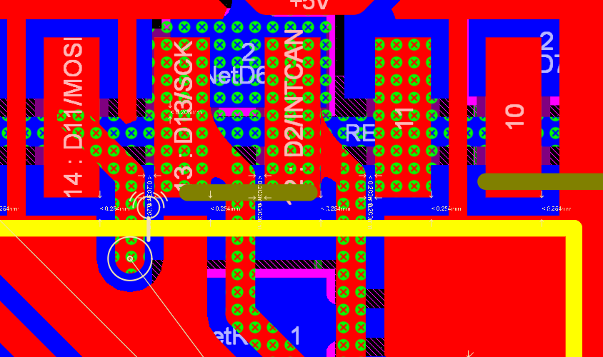

Should add silk screen for debugging switches later on, a label and a box would be nice

Ask tylynn about the CBRB and if it needs to go back out to the car.

Possibly add the reset circuit into the PDU to cut down on one extra board from the car.

The D9 footprint is backwards. The dot is facing ground. Check pins and body.